Client Implementation Tool Process document

The purpose of this tool is to create the new contract, payors and product line with all the contract related dependencies.

This purpose of this document is to show case the Tool implementation process, impediments and assumptions.

Process

The tool will be deployed in two environments INTEGRATION and PRODUCTION.

Tool in Integration

Tool available in integration will be able to communicate with all the other lower AWS environment like BRE, QA and DEV for all the different branches like Caspian, pacific, Baltic.

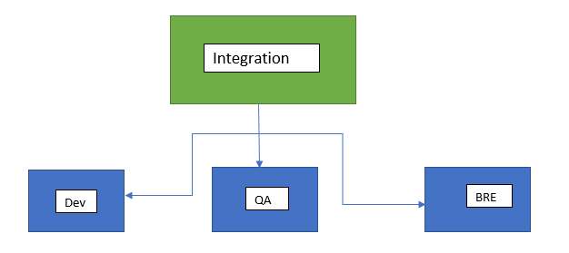

On the creation of contract, it will be created in all the environment at the same time.

**Validations**

1] Contractid, Payorid and ProductLineid will must be same in all the environments. Tool will validate the similarity of max ids in all the environments and if the ids are different then the message will be shown to correct the environments.

2] Contract and related data will only be created if all the environments will have same ids.

**Impediments**

1] If the Contractid, Payorid and ProductLineid are different then the IT Implementation team need to correct the database for the smooth execution of contract creations.

**Assumptions**

1] Tool will be able to access all AWS environment from integration.

2] On change of existing AWS environment and on creation of new AWS environment the configuration of tool need to be modified.

Tool in Production

Tool available in production will be able to communicate with UAT environment. On the creation of contract, the contract and all its dependencies will be created in UAT and Production at the same time.

Any deviation of ids in any environment will be corrected by the IT Implementation team or production support team with manual scripts.

**Validations**

1] Contractid, Payorid and ProductLineid will must be same in all the environments. Tool will validate the similarity of ids in all the environments and if the ids are different then the message will be shown to correct the environments.

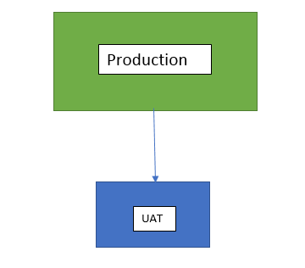

**Assumptions**

1] The ids will always be in sync in Production and UAT environments as they are controlled environments.

2] Tool will be able to access the UAT database from production environment.

3] Configuration will only be modified on change of UAT and Prod environments.

**Advantages**

1] Contract can be created and tested in AWS environment before production.

2] All ids can be maintained as identical in all the environments as the tool will force to make the same to successfully create the contract.

3]The production environment will be independent of AWS environments dependencies.

4] On creation and modification of new AWS environments will only impact tool in Integration environments. Tool present in production can continue without any interruption at the same time.